assignment 1 – WEB322

Eirian (Trang) Ta - 139030191

Table of Contents

I. Overview 2

II. Components 2

1. Model 2

2. View 2

2.1. Homepage 2

2.1.1. Header - Navigation 2

2.1.2. Hero Section 3

2.1.3. Featured Movies Section 3

2.1.4. Featured TV Shows Section 3

2.1.5. Content Sections 4

2.1.6. Footer 4

2.2. Movie & TV Show Listing Pages 5

2.2.1. All Item Listing Page 5

2.2.2. Movie Listing Page 5

2.2.3. TV Show Listing Page 6

2.3. Movie & TV Details Page 6

2.4. Customer Registration 7

2.5. Login 8

3. Controller 8

# Overview

This assignment is the first one of the five that are designed for practical experience in building Dynamic websites and Server-Side Web applications using Node.js and Express.

The website is a more simplified version of the original VUDU website, developed with MVC model. The copyright of all images as well as information belongs to the original one.

# Components

## Model

The data for the Movies & TV Shows are encapsulated into a separate module. For the scope of this first assignment, the data is not pulled from a database but created manually in a JavaScript file called `FakeDB.js`. Each item in the fake database has an id, a title, synopsis, small poster image, large poster image, the price to rent the movie/tv show per day, the price to purchase the movie/tv show outright, a field to determine if it is a movie or tv show, a field that determines if the movie/tv show is to be featured on the home page or not, and some other additional information for the purpose of a more visually appealing display (star, gerne, date, studio, language, score, UHD, HDX, SD, CC).

This module allows filtering featured movies and featured tv shows using the attribute `feature`.

## View

## Homepage

### Header - Navigation

Header contains the navigation bar. The navigation bar has the logo of the website navigating to Homepage and other links that navigate visitors to Movies & TV Show Listing pages, sign up page and login page.

Other links like Free, My Vudu, Redeem and search function will be fully implemented during next assignments.



### Hero Section

This section displays banners and images highlighting the most demanded movies and tv shows of 2021. This is currently implemented as a slide show using `Carousel` from Bootstrap 4, but may be changed during next assignments in order to eliminate the need of loading the whole jQuery library to support the slide show.

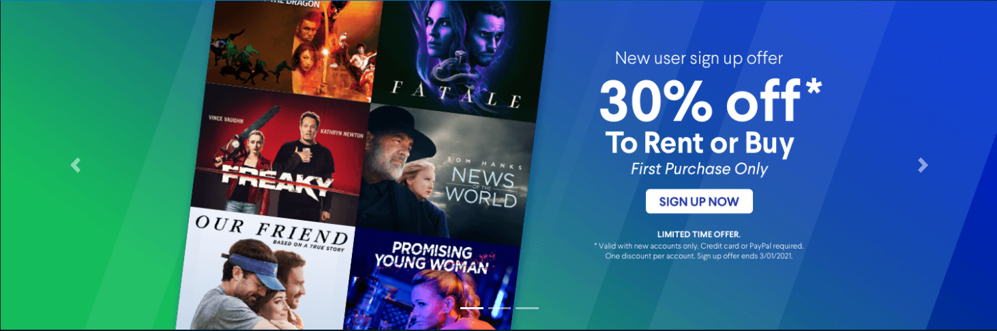

### Featured Movies Section

This section displays all featured movies inside a slider so that the user can swipe left and right to see more movies. The slider is currently implemented using `lightSlider`, but may be changed during next assignments in order to eliminate the need of loading the whole jQuery library to support to slider.

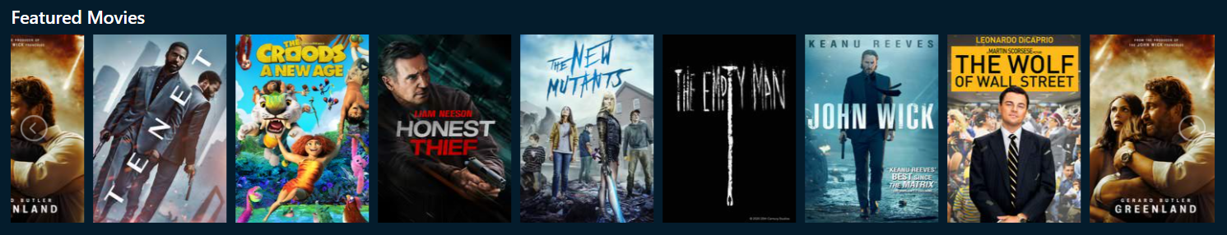

### Featured TV Shows Section

Similar to the `featured movies section`, this section is also currently using `lightSlider`, which may be changed during next assignments for a better performance, to display all featured TV shows.

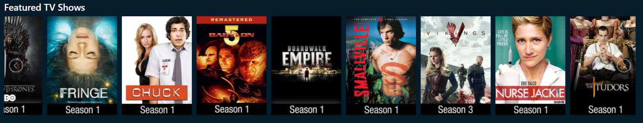

### Content Sections

These sections use a combination of grids, headings and images, with the purpose of highlighting the company’s services and/or exciting details about Hollywood.



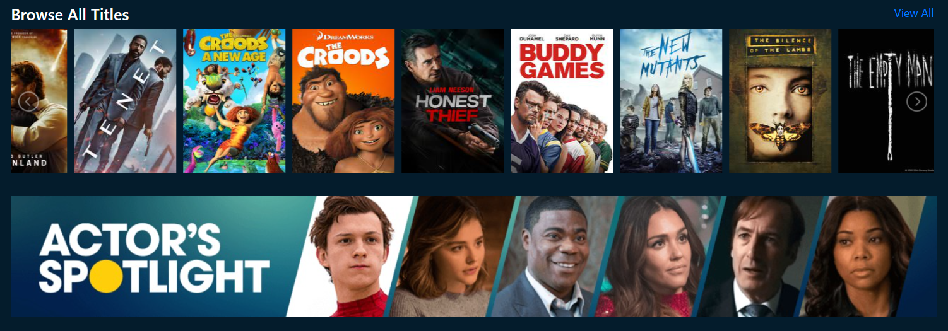

`View All` in this section will navigate visitors to the `All Item Listing Page` (both movies and TV series)

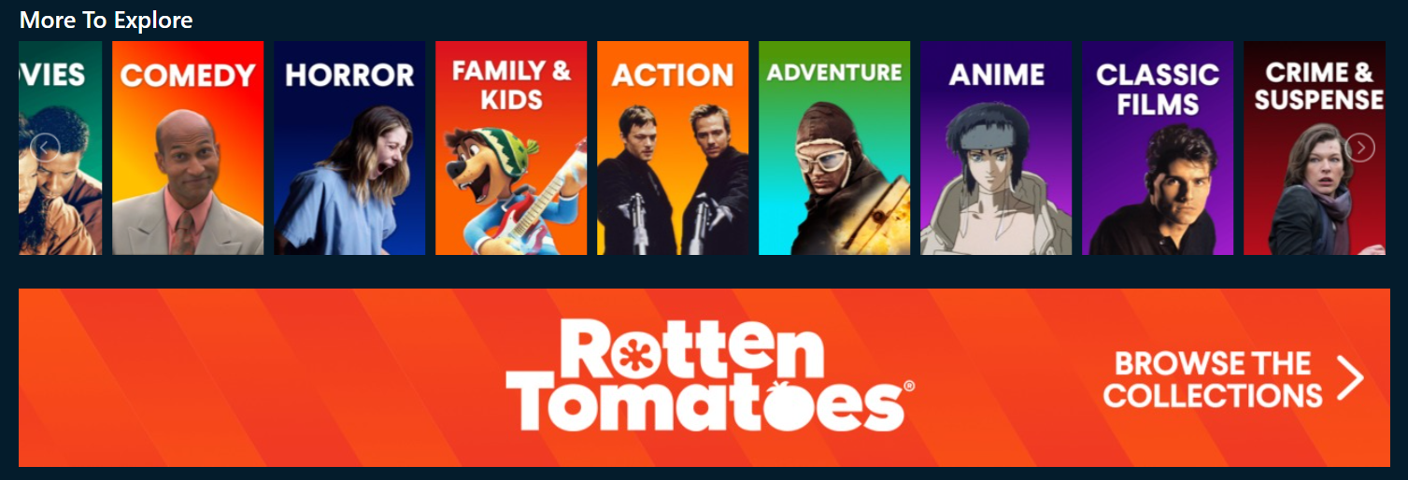

### Footer

This section includes footer menu items, social media links, and my disclaimer.

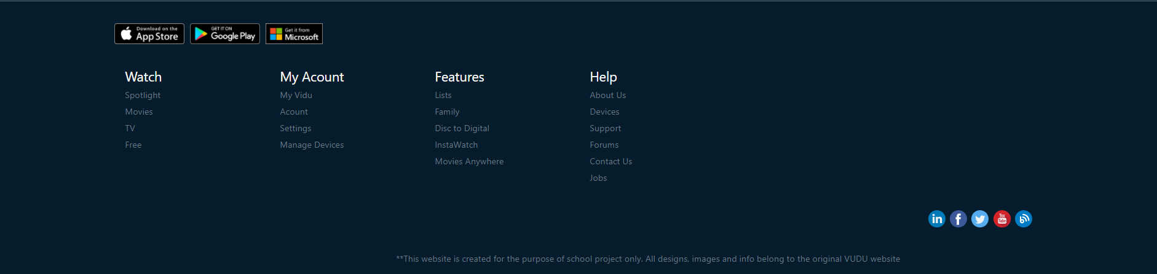

## Movie & TV Show Listing Pages

### All Item Listing Page

This page can be access through `View All` at `Browse All Title` in the content section. This page pulls all the movies and tv shows from the “fake database” and displays the clickable poster of them in a grid. When a user clicks on a respective poster, the user is navigated to the Movie & TV Show Details page for the clicked movie or tv show.

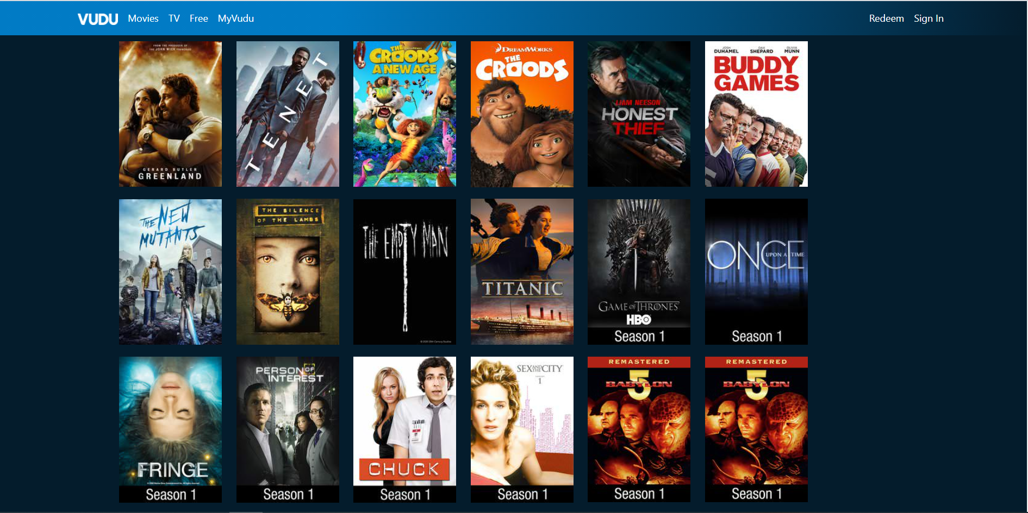

### Movie Listing Page

This page can be access through the top navigator in the header or the link in footer at the bottom of the page. This page pulls all the movies from the “fake database” and displays the clickable poster of them in a grid.

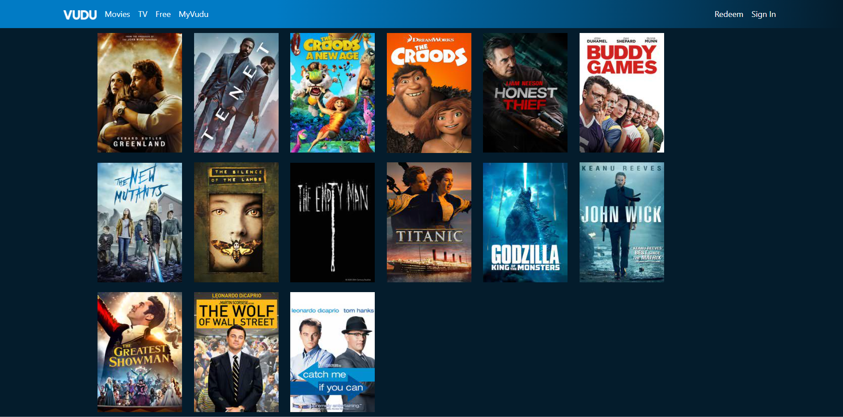

### TV Show Listing Page

This page can be access through the top navigator in the header or the link in footer at the bottom of the page. This page pulls all the TV shows from the “fake database” and displays the clickable poster of them in a grid.

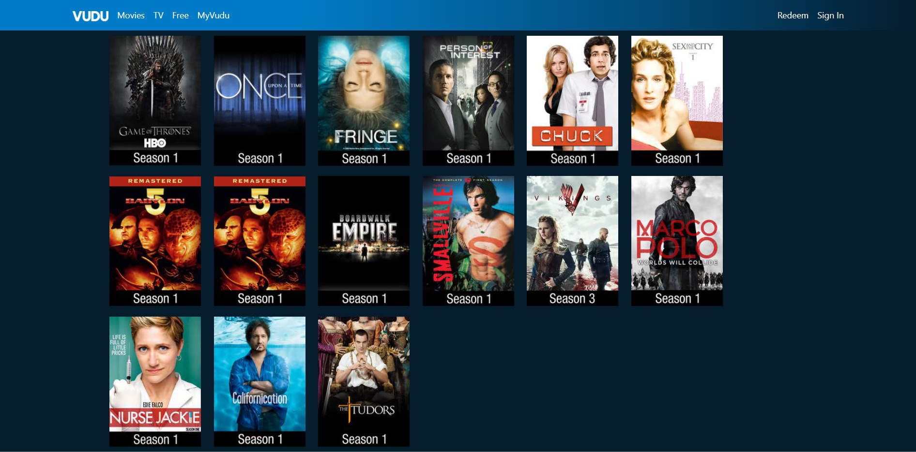

## Movie & TV Details Page

From the listing page, when a user clicks on a particular movie or tv show, they will be navigated this page. The ID of the clicked movie is passed in the URL.

This page lists the title of the movie/tv show, synopsis, small poster, large poster, the price to rent the movie or tv show, the price to purchase it outright and some other additional information.

Here I also added a section called `You May Also Like` which suggests some movies/tv shows that have the same gerne with the movie/tv show the user is looking at.

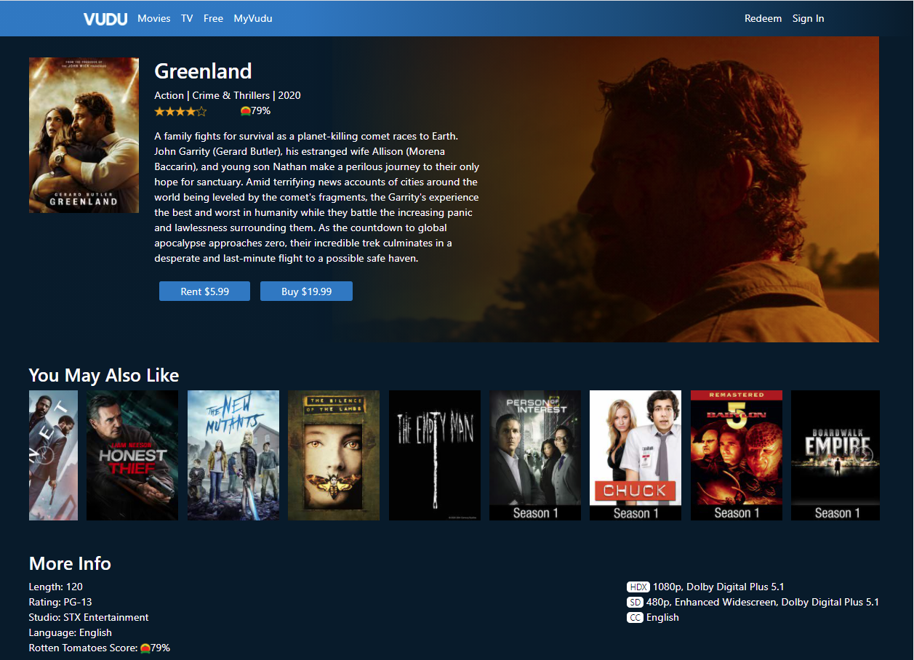

## Customer Registration

This is implemented as an entirely new page with a user registration form.

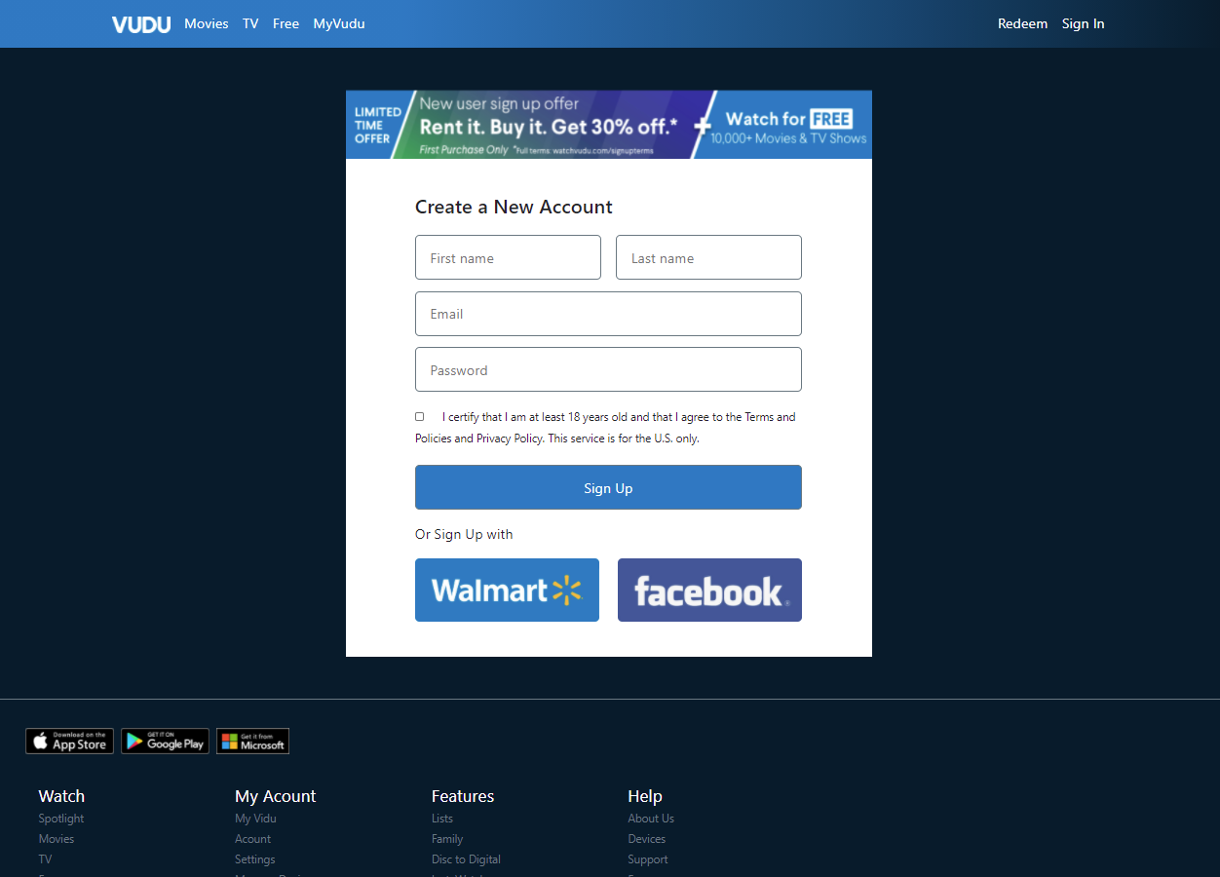

## Login

This is implemented as an entirely new page with a login form.

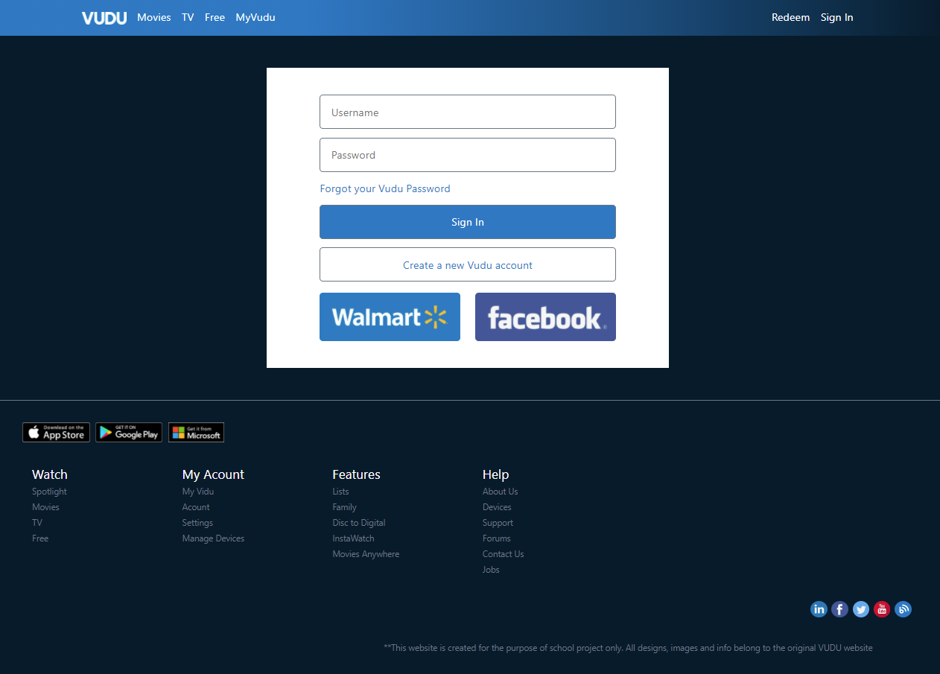

## Controller

For the scope of this assignment, there is only one file `server.js`. All back-end functionality is done using Node JS and Express.